PAIL Assignment 1 - Lab 1



Name : Samarth D Valsange

Roll no: 46  
Enrollment No. ADT24SOCB0996

SY-06 Batch (B)



**1. Hello World (hello.asm)**

This program prints Hello, World! using NASM and Linux system calls.

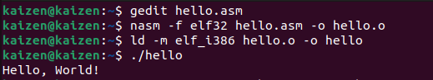

hello.asm file

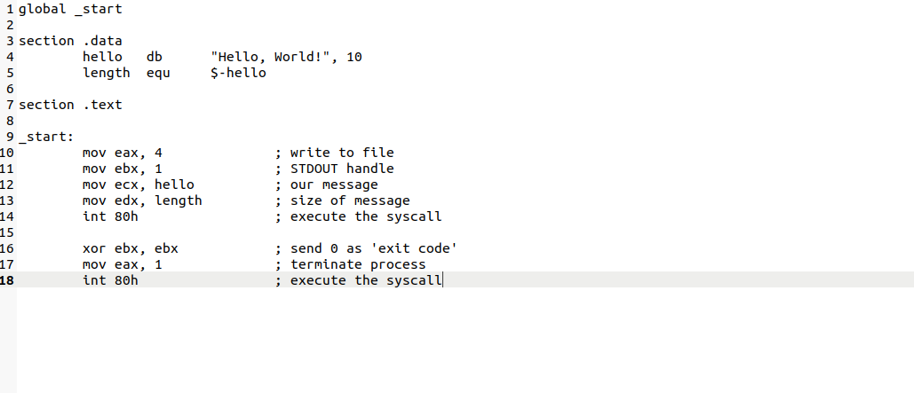



**2. GDB Use on hello.asm**



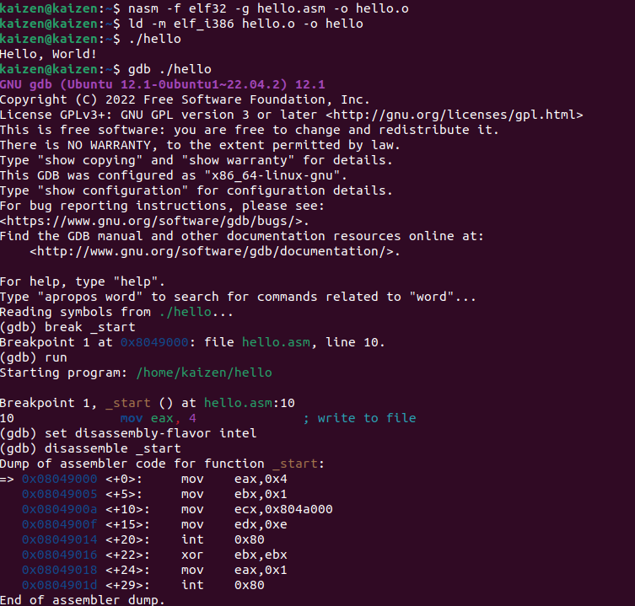

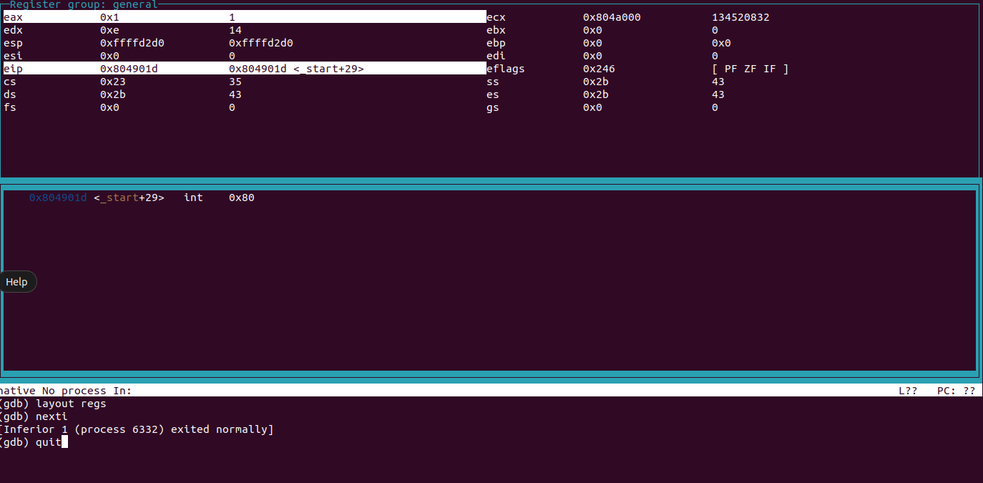



**3. Print First Name and Surname (myname.asm)**



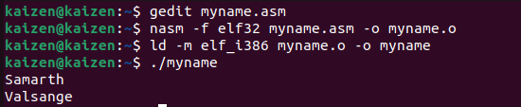

**myname.asm**

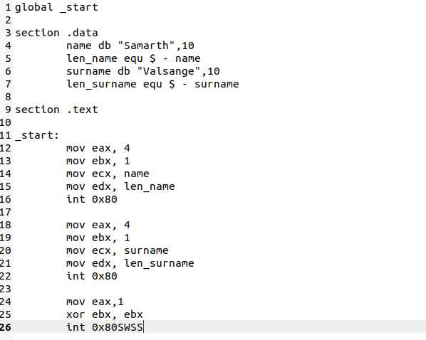



**GITHUB LINK:** [**https://github.com/KaizenPixel/PAI-LAB-ASSIGNMENT.git**](https://github.com/KaizenPixel/PAI-LAB-ASSIGNMENT.git)